

**PRODUCT SPECIFICATION SHEET**

**BAMBINA NAPPY BIN**

# KHP PART No. NAP BIN BAM UNP

### **DESCRIPTION**

* Pedal operated container for nappies.
* Cover designed to obscure contents of nappies from user.
* Plastic Liner can be quickly removed for cleaning.
* Capacity of container : 50 Litres
* Odour control feature.

### **DIMENSIONS**

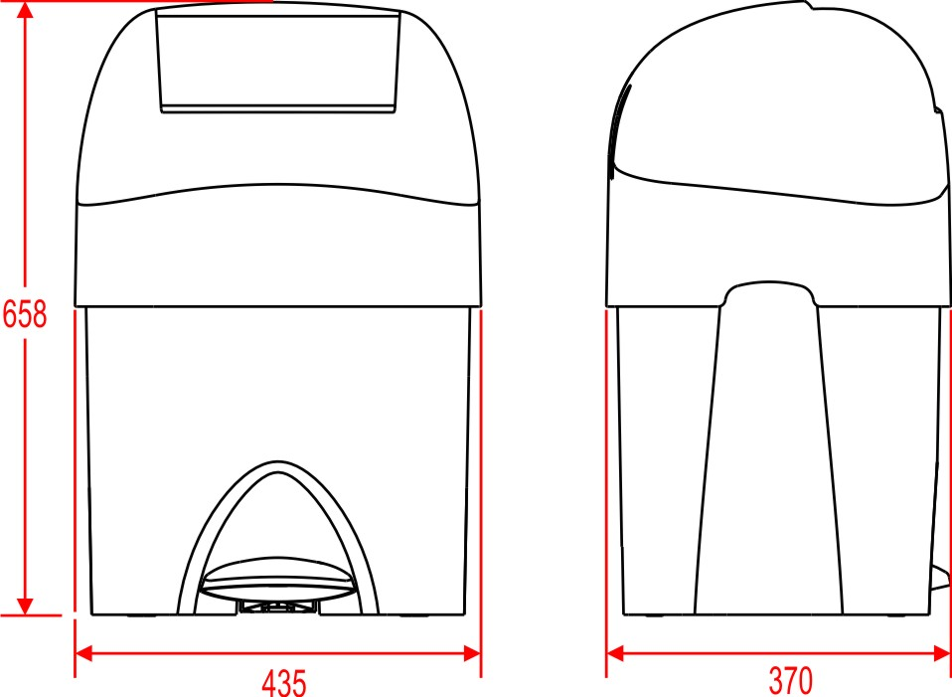

### **MATERIALS**

Constructed from mainly ABS . Dispenser can be recycled or disposed of in accordance with local regulations.

### **PACKAGING**

1 unit is packed into a double wall carton.

Box dimensions: 37.5cm x 42.5cm x 53cm

Individual Weight boxed: 6Kg

